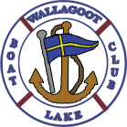
Wallagoot Lake Boat Club 2017 Regatta

NOTICE OF RACE
Saturday 11th & Sunday 12th March, at Wallagoot Lake.
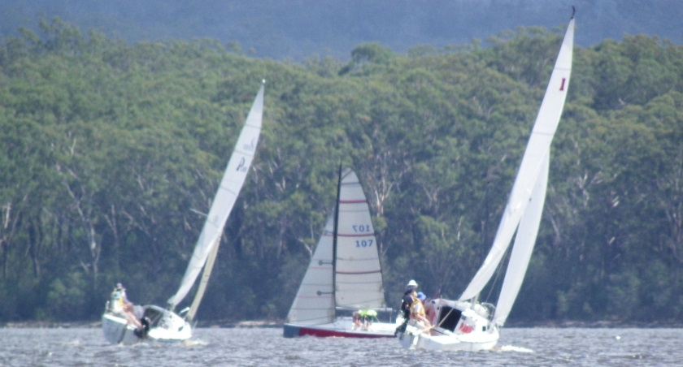
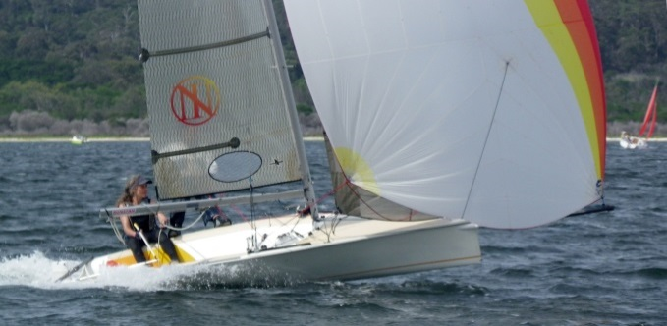
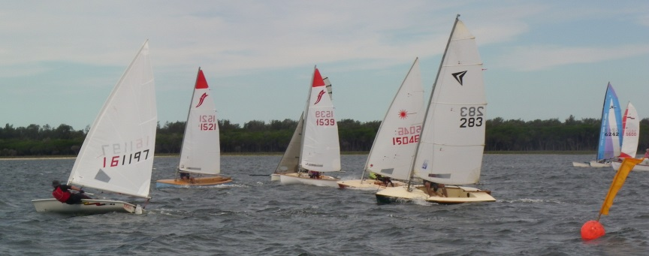
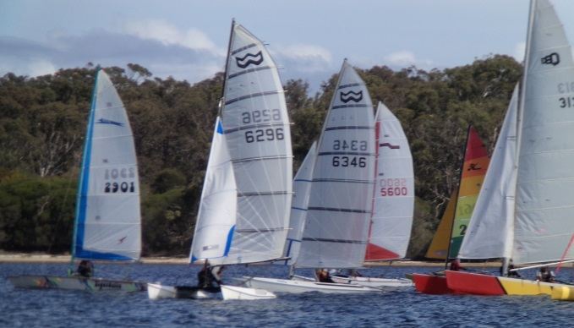
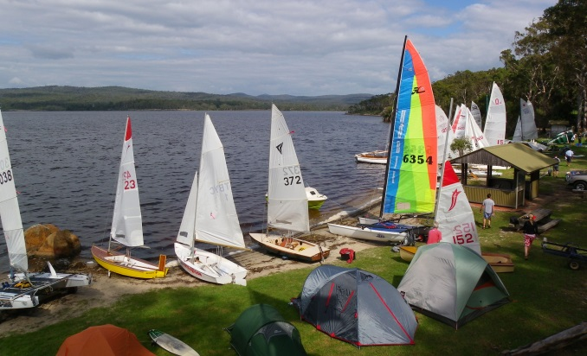
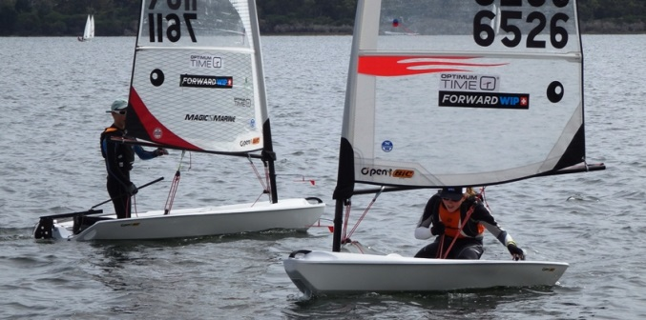
Open to all classes of off-the-beach dinghies, multihulls and trailer-sailors Entries (per boat): $50 or $15 per race
Division 1: monohulls >/113
Division 2: trailer-sailors
Division 3: monohulls <113
Division 4: multihulls
Division 5: monohulls >140

Please note: a $7 per day entry fee applies to vehicles, as the Club is within Bournda National Park. Payment pole is found at the western end of the rigging area.

Event Schedule*:
Registration: 8:30am– 10:00am Saturday
Briefing: 10:00am Saturday
Race One: 11.00 am Saturday
Race Two: 2.00 pm Saturday
Race Three: Back-to-Back Saturday
Dinner: 7pm Saturday
Race Four: 11:00 am Sunday
Race Five: Back-to-Back Sunday
Presentation: ASAP after racing Sunday
* May be varied at the discretion of the WLBC

LOTS OF FUN, CLOSE RACING AND GOOD TIMES!
All classes welcome:
monohulls and multihulls,
learners, juniors and veterans.

The WLBC highly recommend YNSW Membership for personal accident insurance, public liability cover on boats, and disclaim liability for any incidents that occur.

Lunches and drinks available each day
BBQ dinner available on Saturday evening.
Hot showers provided.
Club boats available for hire $10/day:
Manly Junior, Sabot, Spiral, Sabre

For more information contact:
Rob Morton Events Co-Ordinator 0428246903
Terry Kirby Club Secretary 0420460209
See the club’s website: wlbc.org.au

The club can found on Wallagoot Lake Rd, off Sapphire Coast Drive, between Tathra, Bega & Merimbula

